BUS632-30 UNIT 1 ASSIGNMENT

Submitted to

Professor Heidi Nguyen
Post University
Waterbury, Connecticut

July 5, 2021

By
Gordon Elliott Williams

Financial Statements Defined and Valued
Financial statements are varying type4 of records that will show business activities and performance of a corporation. “The financial statements are used by investors, market analysts, and creditors to evaluate a company's financial health and earnings potential. The three major financial statement reports are the balance sheet, income statement, and statement of cash flows (Murphy, 2020).” While working as a low-level accounting clerk for a large, international distributor, these statements were regularly provided (or at least the bottom line of the number totals) to every employee in our quarterly meetings. “Balance sheets show what a company owns and what it owes at a fixed point in time. Income statements show how much money a company made and spent over a period of time. Cash flow statements show the exchange of money between a company and the outside world also over a period of time (Beginner’s Guide, 2007). “ Each statement has a specific function and provides particular information to whatever party has it in review.
The Balance Sheet is usually considered the most important of the three financial statements because it provides intimate details. Those details include “Use of debt and equity, Asset Creation, Net worth of the Company, Current asset/current liability status, cash available, fund availability to support future growth, etc. (Thakur, n.d.).” Debit and equity references liabilities, or how much is owed, and the amount of investments are poured into the business. Asset creation references how much the company actually owns. “The balance sheet is based on the fundamental equation: Assets = Liabilities + Equity.” On the Balance Sheet, Assets, Liabilities, and Equity (Shareholders) are all totaled into various sections. Total Assets equate to Current Assets and Non-Current Assets. Total Liabilities equate to Current Liabilities and Non-Current Liabilities. And Total (Shareholders) Equity equates to Shared Capital and Retained Earnings.
Things that are current and non-current actually confused me initially. But after some further research, I found that each one has its own particular definition. “Noncurrent assets are a company's long-term investments that are not easily converted to cash or are not expected to become cash within an accounting year. Examples of noncurrent assets include investments, intellectual property, real estate, and equipment (Kenton, 2021).” “Current liabilities (short-term liabilities) are liabilities that are due and payable within one year. Non-current liabilities (long-term liabilities) are liabilities that are due after a year or more (Types of Liabilities, n.d.).” Examples of Current Liabilities versus Non-Current Liabilities are as follows:
Current Liabilities | Non-Current Liabilities
Accounts Payable | Bonds payable
Interest payable | Long-term notes payable
Income taxes payable | Deferred tax liabilities
Bills payable | Mortgage payable
Bank account overdrafts | Capital leases
Accrued expenses
Short-term loans

Shareholders Equity is usually reported on the Balance Sheet as the following:
- Treasury Stock;
- Retained Earnings;
- Paid-In Capital; and,
- Accumulated Other Comprehensive Income.
To bring it all together, below is a sample Balance Sheet with all of the aforementioned sections in detail:
Figure 1.
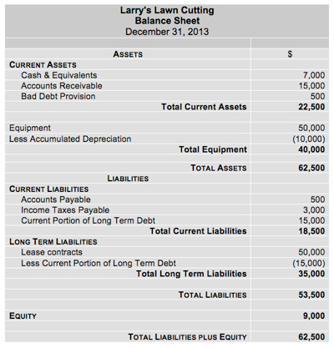
Next in line is the Income Statement. The Income Statement has three primary sections: Gross Profit, Operating Expenses, and Net Income. The Income Statement follows the formula:
NET INCOME = GROSS PROFIT – OPERATING INCOME.
Gross Profit includes Sales and Cost of Sales. Gross Profit is the SALES – COST OF SALES. Total Operating Expenses contains things like Cost of Goods Sold, Marketing and Promotions, Administrative costs, or Research and Development. Following is a sample Income Statement:
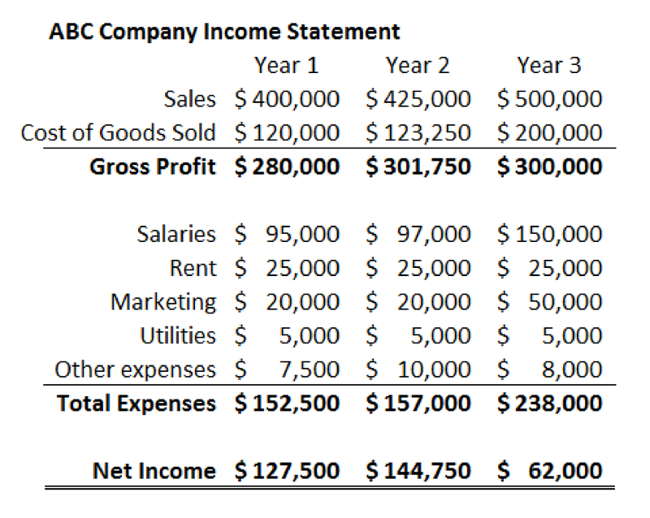
Lastly, lets take a quick look at the Cash Flow Statement. “The importance of cash flow statement is that it is used to measure the cash position of the business i.e. the inflow and outflow of cash and cash equivalents in the business for an accounting year and it also helps the business to know the availability of cash in their business (Thakur, n.d.).” Essentially, it tells the strength and profitability of a business. There are four primary reasons why a Cash Flow Statement is important:
- “A Cash Flow Statement can help you focus on creating excess cash.
- Cash Flow Statements often provide better Key Performance4 Indicators than profit and loss statements.
- Cash Flow Statements help with financing decisions; and,
- Cash Flow Statements tells you where the money went (Patrick, n.d.).”
Following is are two samples of Cash Flow Statements:
Figure 2.
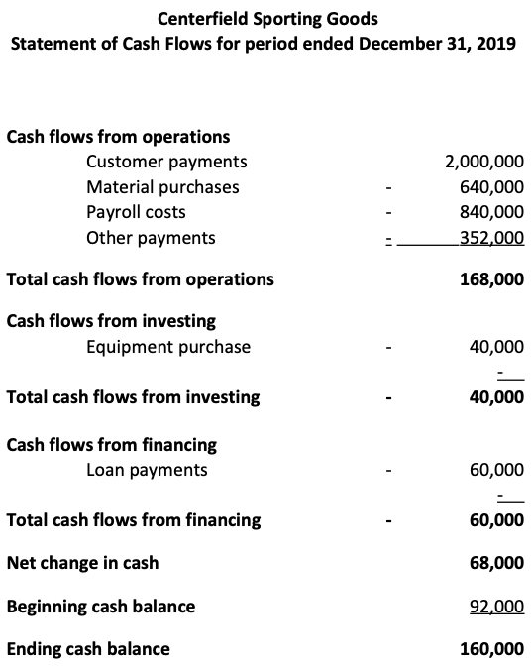
Figure 3.
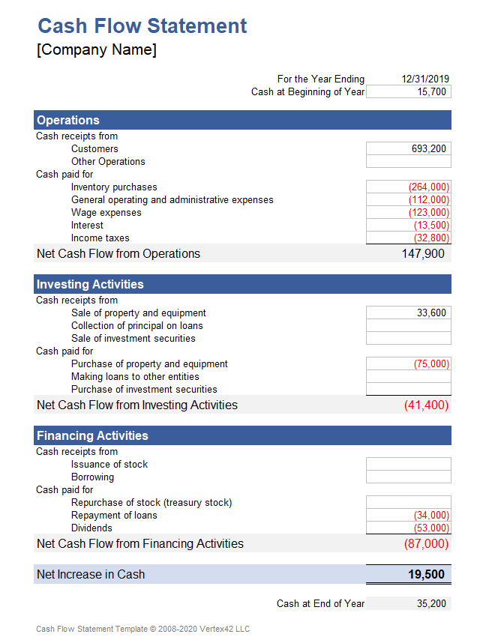
In closure, analyzing financial statements is tantamount because shareholders/stakeholders need as much information as possible to make responsible decisions for the company’s financial future. To make these decisions, there is a need for accurate reporting on all of the financial statements.

References

Murphy, C. 09 Sep 2020. “Financial Statements.” Retrieved from: https://www.investopedia.com/terms/f/financial-statements.asp
Beginner’s Guide To Financial Statements. 05 Feb 2007. U.S. Securities and Exchange Commission. Retrieved from: https://www.sec.gov/reportspubs/investor-publications/investorpubsbegfinstmtguidehtm.html
Thakur, M. n.d. “What Is The Purpose of the Balance Sheet?” Retrieved from: https://www.wallstreetmojo.com/balance-sheet-purpose/
Kenton, W. 27 Apr 2021. “Noncurrent Assets.” Retrieved from: https://www.investopedia.com/terms/n/noncurrent-assets.asp
Types of Liabilities. N.d. Corporate Finance Institute. Retrieved from: https://corporatefinanceinstitute.com/resources/knowledge/accounting/types-of-liabilities/
Fig. 1. Balance Sheet – Assets, Liabilities, and Equity. N.d. Free Management Books. Retrieved from: http://www.free-management-ebooks.com/faqfi/balance-02.htm
Thakur, M. n.d. “Cash Flow Statement Importance.” Retrieved from: https://www.wallstreetmojo.com/cash-flow-statement-importance/
Patrick, J. n.d. “4 Reasons A Cash Flow Statement Is Important.” Retrieved from: https://www.stage2planning.com/blog/bid/60143/4-reasons-a-cash-flow-statement-is-important
Fig. 2. Boyd, K. 08 Apr 2020. “How To Prepare and Analyze a Statement of Cash Flows.” Retrieved from: https://quickbooks.intuit.com/r/growing-complex-businesses/how-to-prepare-and-analyze-a-statement-of-cash-flows/
Fig. 3. Cash Flow Statement Template. 14 May 2020. Vertex42. Retrieved from: https://www.vertex42.com/ExcelTemplates/cash-flow-statement.html

